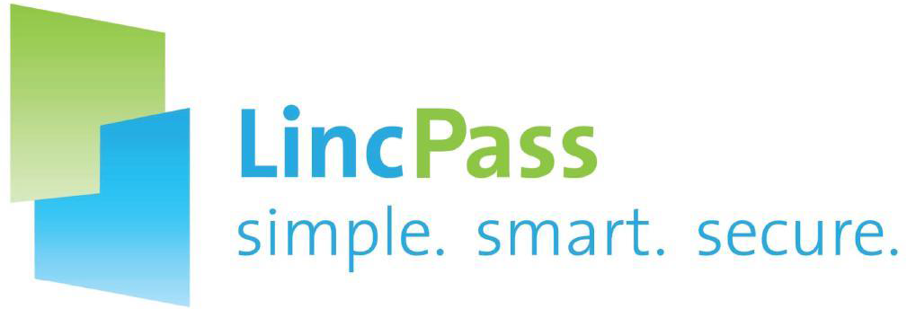
Natural Resources Conservation Service

Conservation Partners
  - LincPass Issuance Update
A summary of current status of LincPass issuance for Conservation Partners, a breakdown of issues affecting those who do not have LincPass, and a synopsis of targeted actions to resolve those issues.

Associate Chief for Operations
Office of the Chief Human Resource Officer
Workforce Management Division
Staffing & Workforce Management Branch
Personnel Security and Suitability Team
February 2017

LincPass and Conservation Partner Employees

Why LincPass?
Homeland Security Presidential Directive 12 (HSPD-12) was issued on August 12, 2004 by President George W. Bush; it called for a mandatory, government-wide standard for secure and reliable forms of ID issued by the federal government to its employees, contractors and others that:
- is based on sound criteria for verifying an individual's identity;
- is strongly resistant to identity fraud, tampering, counterfeiting, and terrorist exploitation;
- can be rapidly authenticated electronically; and
- is issued only by providers whose reliability has been established by an official accreditation process.
The LincPass is USDA’s implementation of HSPD-12.

Current Status for Conservation Partners
The following shows the current status of LincPass issuance for Conservation Partners as of 2/6/2017:
Status | Number | Pct
Have Active LincPass | 3,700 | 96.7%
Do Not Have LincPass (not requested, not enrolled, not adjudicated and/or not picked up) | 127 | 3.3%
Total Conservation Partners | 3,827 | 100%
Note: These numbers reflect login accounts that are active as of 2/6/2017

LincPass Process Steps
The process for issuing a LincPass involves the following major steps:
What | Who | How
Sponsorship | NRCS Sponsor * | Validates need for a LincPass, enters data into system
Enrollment | Applicant | Provides proof of identity, scans fingerprints, takes photo
Adjudication | NRCS Adjudicator ** | Submits fingerprints to OPM, adjudicates results
Activation | Applicant | Picks up card, creates unique PIN, activates LincPass
* NRCS Sponsor – a state designated point of contact who determines that a Conservation Partner requires a LincPass, and initiates the request for the Conservation Partner to enroll for a LincPass.
** NRCS Adjudicator – reviews the results of background investigations and records the results in EmpowHR Person Model. For this purpose, the NRCS Adjudicator is anyone on the Personnel Security Team.

Challenges Identified; Plan of Action to Address
Summary of current challenges that prevent LincPass issuance:
Challenge | Number | Resolution
Not Sponsored | 3 | Ensure all CD employees are sponsored by NRCS for LincPass
Not Enrolled | 26 | Reach out to applicants and encourage them to enroll ASAP
Not Adjudicated | 71 | Targeted effort to adjudicate all CD employees
Not Activated | 30 | Reach out to applicants and encourage them to pick up and activate their LincPass ASAP

Resource
Conservation Partners with questions or issues regarding issuance or usage of the LincPass can send an email to LincPass@wdc.usda.gov for assistance.
For those who are interested in becoming partners, NRCS has designated POCs in each state. Please contact the state office for more information and assistance.
January 2017

