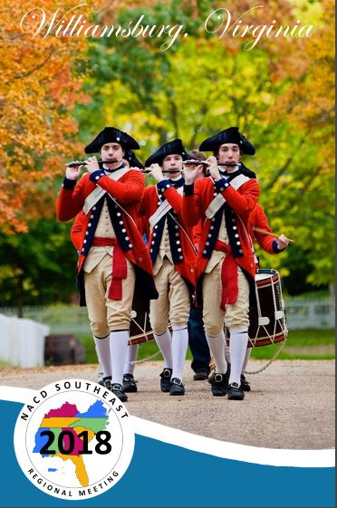

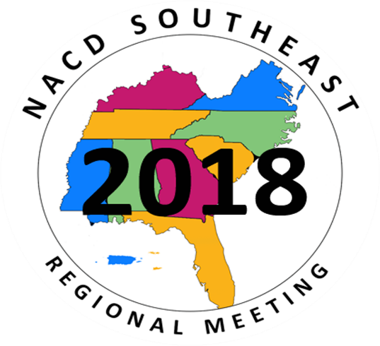

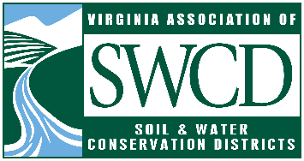
August 3 – 8, 2018 ∙ Williamsburg, Virginia
Williamsburg, Virginia

THANK YOU
A special thank you to the following companies, groups and organizations for their support of the joint 2018 Southeast National Association of Conservation Districts Regional Meeting & NACD Summer Conservation Forum & Tour:

Silver Sponsor:

A Special Thanks To::
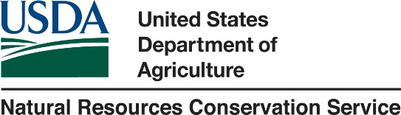
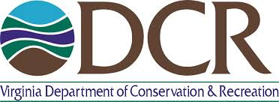

Welcome to Williamsburg, Virginia!
It is our honor to host you for the next few days. We hope your stay in Williamsburg and participation in the meeting meets all of your expectations. Our goal is to make your stay both enjoyable and educational. If at any time we can be of assistance, please don’t hesitate to stop by the registration desk or reach out to someone from the Virginia team.

We have a great meeting planned with excellent concurrent sessions, motivational speakers, and informative field trips as well as a number of fun activities to perk your enthusiasm and enjoyment. The Williamsburg Lodge is an ideal venue for this meeting as it offers a relaxed atmosphere, wonderful meeting facilities, and cultural activities that you will enjoy.

The theme for this 2018 meeting is “Where Leaders Meet,” fitting for our time in Williamsburg as it’s steeped in history rich of leadership. Williamsburg was founded as the capital of the Virginia Colony in 1699. The original capital, Jamestown was the first permanent English-speaking settlement in the New World founded in 1607. Colonial leaders petitioned the Virginia Assembly to relocate the capital from Jamestown to Middle Plantation, five miles inland between the James and the York Rivers. The new city was renamed Williamsburg in honor of England's reigning monarch, King William III.
Williamsburg was one of America's first planned cities, laid out in 1699. It was to be a city suitable for the capital of the largest and most populous of the British colonies in America. A succession of beautiful capitol buildings became home to the oldest legislative assembly in the New World. The young city grew quickly into the center of political, religious, economic and social life in Virginia. The city also became a center of learning. Famous political leaders emerged from the College of William and Mary, such as Presidents Thomas Jefferson, James Monroe, and John Tyler.
The Capital was again moved in 1780, this time up the James River to Richmond, where it remains today. In retrospect, Williamsburg's loss of capital city status was its salvation as many 18th century buildings survived into the early twentieth century. The Restoration of Williamsburg began in 1926, when John D. Rockefeller, Jr., led the massive reconstruction of the 18th century city we see today. During a landmark visit in 1934, Franklin D. Roosevelt proclaimed its main thoroughfare, the Duke of Gloucester Street, "the most historic avenue in America." Today, Williamsburg is known internationally as the premier center for the preservation and interpretation of American colonial history.
Much like Williamsburg, our program will recognize our history all while embracing our future. The program is designed to stimulate your thoughts, challenge you to think outside the box, and offer ideas that you can take home to help build the capacity of the conservation program in your area.

2018 NACD Conservation Forum, Tour &

Southeast Regional Meeting

FRIDAY, AUGUST 3, 2018
7:00AM – 12:00PM NACD Officer Meeting Jefferson Boardroom
12:00AM – 5:00PM NACD Executive Board Meeting Jefferson Boardroom

4:00PM – 6:00PM Registration Open Registration Desk #1

SATURDAY, AUGUST 4, 2018

8:00-5:00PM Registration Open Registration Desk # 1

9:00AM -12:00PM NACD Board of Directors Meeting Colony DE

2:00 – 4:00PM NACD Committee Meetings
Communications Colony A
District Operations/Member Services Colony B
Legislative Tidewater AB
Natural Resource Policy Tidewater CD
Stewardship & Education Colony C

4:00PM -5:00PM NACD Farm Bill Task Force Meeting Tidewater AB

SUNDAY, AUGUST 5, 2018

8:00-6:00PM Registration Open Registration Desk #1

9:00AM -11:00AM NACD Board of Directors Meeting Colony DE

11:00AM -5:30PM Project WET Workshop Tidewater D

1:00PM -3:00PM SE NASCA Meeting- All NASCA Welcome
Vernon Cox, Presiding Alleghany ABC

2:00 – 3:30PM NACD Region Meetings
North Central Colony A
Northeast Colony B
Northern Plains Colony C
Pacific Tidewater A
South Central Tidewater C
Southeast Piedmont ABC
Southwest Tidewater B
SUNDAY, AUGUST 5, 2018

3:00PM Exhibit Hall Opens Virginia Foyer

4:00-5:00 PM Conservation Partnership Round Tables
North Central Colony A
Northeast Colony B
Northern Plains Colony C
Pacific/SW Region Tidewater A
South Central Tidewater C
Southeast Piedmont ABC

6:00 – 8:00 PM Southeast Region Social-Welcome to VA Reception Virginia Ballroom, Virginia Lawn & Foyer
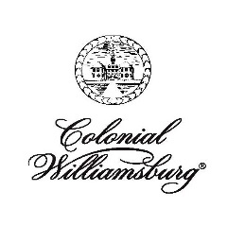
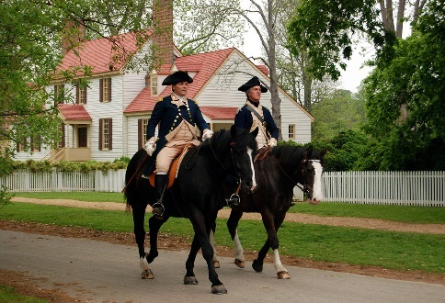
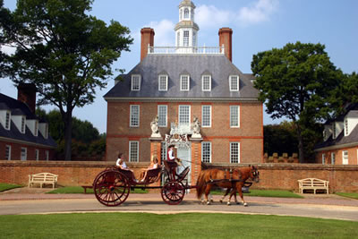
The letters “WR” are included on your nametag if you purchased this in advance.
WELCOME TO WILLIAMSBURG!
Please join us for a casual evening of fellowship to mingle with meeting attendees and kick off conversation. Enjoy a variety of hors d’oeuvres and beverages while you network with fellow attendees. Be sure to stroll through the exhibit hall highlighting Virginia’s conservation partners and more.
Join us on the Virginia Lawn to experience life as it was in the 18th Century. Participate in Colonial lawn games and interact with the Chowning Traveling Band of 18th Century Performers. Then take time to walk through the Northern Neck Soil & Water Conservation District soil trailer and the Spotsylvania Environmental Education Development mobile education platform. Guided tours available during our evening social.
Following our reception, continue the libations if desired a few feet away at the same Taverns frequented during the Revolution.

MONDAY, AUGUST 6, 2018

7:00 AM –5:00PM Registration Registration Desk #1

7:30AM-8:30AM Breakfast Available Virginia Foyer

8:30AM General Session Virginia Room A-F

Invocation
Led by Giannina DiMaio, VASWCD 2nd Vice President

Presentation of Colors & National Anthem
TBD – Colonial Williamsburg

Pledge of Allegiance
Led by Chip Jones, VASWCD 1st Vice President

Welcome
Steven Meeks, VASWCD President
Brent VanDyke, NACD President

Opening Remarks
Invited: Pam Northam, First Lady/ Matt Strickler, Secretary of Natural Resources

Keynote Speakers:
Bill Northey, Under Secretary
United States Department of Agriculture

Ross Melinchuk, VP of Conservation
Wild Turkey Federation

Clyde Cristman, Director
Virginia Department of Conservation & Recreation

10:15 – 10:30AM BREAK – Visit the Exhibit Hall
DID YOU KNOW?
Agriculture is Virginia’s largest private industry. The industry has an economic impact of $70 billion annually and provides more than 334,000 jobs in the Commonwealth. The industries of agriculture and forestry together have a total economic impact of over $91 billion and provide more than 442,000 jobs.

Monday Guest Speakers

Bill Northey
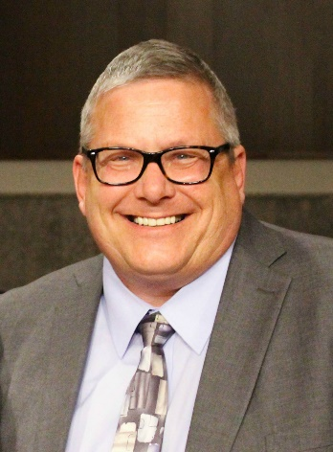
Under Secretary Bill Northey was confirmed in February 2018 to oversee the United State Department of Agriculture’s farm production and conservation mission area, which includes the Farm Service Agency (FSA), the Risk Management Agency (RMA), and the Natural Resource Conservation Service (NRCS).

Previously Northey served as the Secretary of Agriculture of Iowa where he led the Iowa Department of Agriculture and Land Stewardship. Northey previously held the position of District Commissioner for the Dickinson County Soil & Water Conservation District in Iowa.

Clyde Cristman
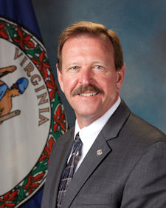
Clyde Cristman became director of the Virginia Department of Conservation & Recreation on April 1, 2014 having been appointed by Governor Terry McAuliffe and reappointed by Governor Ralph Northam. He has more than 30 years of experience in budgeting, strategic planning, human resource management and oversight of various state and local government programs.

Prior, he served as Legislative Fiscal Analyst for the General Assembly Senate Finance Committee. In that capacity, he advised senators on agriculture, forestry, natural resources, land conservation, Chesapeake Bay clean-up, land preservation tax credits and more. He also monitored agencies’ expenditures and compliance with state laws, regulations and policies.

Cristman has served as Deputy Secretary of Public Safety, directed the Virginia Department of Charitable Gaming, served the House Appropriations Committee as a legislative fiscal analyst, and directed the Hampton-Newport News Criminal Justice Agency for six years starting in 1992.

MONDAY, AUGUST 6, 2018
10:30 – 11:30AM Concurrent Sessions*
#1 – Water Words that Work: Closing the Deal with Rural Landowners Piedmont BC

#2 – Meaningful Watershed Educational Experience (MWEE) Efforts from NOAA Tidewater ABCD

#3 – Virginia Urban Agriculture NACD Grant Recipients Showcase Alleghany AB

#4 – Forestry: Generation Next Colony ABC

*See following pages for session descriptions

Noon – 2:00PM SE Conservation Hall of Fame Luncheon Virginia Room A-F
Steven Meeks, VASWCD President, Presiding
HoF” is included on your nametag if you purchased meal in advance.

2:15 – 3:15PM Concurrent Sessions*
#1 – Water Words that Work: Closing the Deal with Rural Landowners Piedmont BC

#2 – Virginia Conservation Assistance Program (VCAP): An Urban Cost Share Program Tidewater ABCD

#3 – Soil Health Session Alleghany AB

#4 – Envirothon: VA Dominion Envirothon Showcase & NCF Envirothon Updates Colony ABC

*See following pages for session descriptions

3:30 – 4:30PM Concurrent Sessions*
#1 – Water Words that Work: Closing the Deal with Rural Landowners Piedmont BC

#2 – Coastal Topics: Bounty of the Bay Tidewater ABCD

#3 – Resource Stewardship Evaluation Tool Alleghany AB

#4 – Tribal Outreach & Partnership Colony ABC

*See following pages for session descriptions

4:30PM Free time/Dinner on your own

5:00PM Virginia Association of Conservation District Employees (VACDE) Business Meeting Tidewater ABCD
MONDAY CONCURRENT SESSIONS: 10:30AM-11:30AM

SESSION #1 Water Words that Work: Closing the Deal w/ Rural Landowners
Speaker: Erik Eckl, Water Words that Work

Learn tricks of the trade that have proven beneficial to getting voluntary conservation projects on the ground. Explore the demographics of rural landowners and their perspectives on voluntary conservation programs. Spot the telltale signs that a landowner might be receptive to your offer. Hear how “ag whisperers” cultivate their personal reputation among landowners and help them reach a decision to pursue conservation measures, and more. This session will continue throughout the day building on the curriculum.

SESSION # 2 Meaningful Watershed Educational Experience (MWEE)
Moderator: Elaine Tholen, Director – Northern VA SWCD/Co-founder NoVA Outside

Speakers:Shannon Sprague, Manager Environmental Literacy & Partnerships, NOAA; Bronwen Rice, B-WET National Edu Program Coordinator, NOAA

Meaningful Watershed Educational Experiences (MWEE) are multi-stage activities that include learning both outdoors and in the classroom and aim to increase the environmental literacy of all participants. Hear local examples where MWEE programs are funded. Leave with solid examples of how to further MWEE work in your own district.

SESSION #3 VA Urban Agriculture NACD Grant Project Showcase
Moderator: Jim Wallace, District Manager – Colonial SWCD

Speakers: New River SWCD, Colonial SWCD, Lord Fairfax SWCD, &Henricopolis SWCD

Learn about the innovative projects underway in Virginia thanks the NACD Urban Agriculture Grant. Colonial SWCD and Lord Fairfax are creating an interactive youth gardening experience. Henricopolis SWCD has created a farm-to-school project in the greater metropolitan Richmond region and New River SWCD is training residents and students thru demonstrations to develop family sized urban ag plots.

SESSION #4 Forestry: Generation Next – Legacy Planning
Moderator: Richard Street, Director – Tri-/County/City SWCD & Chairman Virginia Soil & Water Board

Speakers: Mike Santucci, VA Department of Forestry (DOF) & Adam Downing Virginia Cooperative Extension (VCE)

The Southeastern region is in the midst of high-risk land decisions by over 5 million family forest owners. What will happen to land as it transitions from the hands of the current generation? Without discussion and planning it often ends up parcelized and sold, thereby losing a family heirloom and risking non-farm/forest uses for that property. Transitioning these acres intact and in forest to the next generation is paramount; given our unique role, it is something we can impact. This session will inspire and equip you with awareness, knowledge and simple tools to positively impact land and landowners for generations to come.
MONDAY CONCURRENT SESSIONS: 2:15PM-3:15PM

SESSION #1 Water Words that Work: Closing the Deal w/ Rural Landowners
Speaker:
Erik Eckl, Water Words that Work

Learn tricks of the trade that have proven beneficial to getting voluntary conservation projects on the ground. This session builds on the curriculum presented in the AM portion. It is recommended to attend more than one session.

SESSION # 2 VA Conservation Assistance Program: Urban Cost Share
Speaker: Kevin McLean, VCAP Coordinator, VA Assn of SWCDs

The Virginia Conservation Assistance Program (VCAP) is an urban cost-share program of the VA Assn of Soil & Water Conservation Districts that provides financial incentives and technical and educational assistance to property owners installing eligible Best Management Practices (BMP’s) in Virginia’s Chesapeake Bay Watershed. Learn how this once pilot program has grown to be the latest in demand effort of the VASWCD and districts.

SESSION #3 Soil Health Session: A Partnership Approach to Building Soil Health on Grazing Lands
Moderator: Matt Kowalski, Chesapeake Bay Foundation (CBF)

Speakers:
J.B. Daniel, NRCS Grassland Agronomist & Alston Horn, CBF Field Technician

Partnerships are key to getting the soil health message to farmers, helping them understand associated management practices/techniques that lead to healthier soil, and getting them interested in applying these principles in their operations. Virginia NRCS has had great success with a multi-faceted approach that focuses on educating staff, industry partners, and farmers in the same setting. By leveraging resources, NRCS and partners have implemented new initiatives and innovative approaches to outreach and educations. Join us as we share how we have worked with partners to get producers involved, educated and motivated to make soil health a major priority on their grazing lands.

SESSION #4 Envirothon: VA Dominion Envirothon & NCF Updates
Moderator: Richard Street, Director – Tri-/County/City SWCD & Chairman Virginia Soil & Water Board

Speakers: VASWCD Representative, Envirothon Coach, & NACD National Conservation Foundation Representative

Learn about the unique partnership between the Virginia Association of Soil & Water Conservation Districts and Dominion Energy in support of the Dominion Energy Envirothon program. Review Virginia Envirothon resources that can be used in your own local district. Hear program updates and more regarding the upcoming 2019 Envirothon to be held in the Southeast Region at North Carolina State University.
MONDAY CONCURRENT SESSIONS: 3:30PM-4:30PM

SESSION #1 Water Words that Work: Closing the Deal w/ Rural Landowners
*Note this session will run until 5pm and builds off on curriculum presented in the AM

Speaker: Erik Eckl, Water Words that Work

Learn tricks of the trade that have proven beneficial to getting voluntary conservation projects on the ground. It is recommended to attend more than one session on this topic as the curriculum builds throughout the day.

SESSION # 2 Coastal Topics - Bounty of the Bay: Successes in Oyster Restoration & Aquaculture in the Chesapeake Bay
Moderator: Keith Boyd, NRCS Assistant State Conservationist for Field Operations

Panel:J eff Jones, NRCS State Biologist; Andrew Button, VA Marine Resource Commission (VMRC); Karen Hudson, VA Institute of Marine Science (VIMS)

Until the 1980s, oysters supported the most valuable fishery in the Bay. Unfortunately, decades of pollution, overharvesting, and disease reduced the Bay’s native oyster population to a fraction of historic levels. Fortunately, partners are successfully working to increase wild oyster populations and aquaculture opportunities for harvesters. CBF’s oyster restoration programs offer citizens the tools and info needed to help restore native oysters. The NRCS is also offering funding through a RCPP project with the VMRC and VIMS to help oyster growers improve water quality and increase oyster habitat in the Chesapeake Bay and its tidal tributaries.

SESSION #3 Resource Stewardship Evaluation Tool (RSET)
Moderator: TBD

Speakers: NRCS-USDA Representative

The Resource Stewardship Evaluation Tool is a new tool and service that strengthens and modernizes conservation planning and helps farmers, ranchers and forest landowners better identify their conservation goals and improve their outcomes. This tool enhances the conservation planning process integrating many of NRCS’ planning tools into one package. Learn about RSET development and integration into the Conservation Desktop Streamlining Initiative (CDSI).

SESSION #4 Tribal Partnerships
Moderator: Chip Jones, VASWCD 1st VP/Director, Northern Neck SWCD & Dave Vogel, NACD Tribal RPG Advisor

Speakers: Jerry Pardilla, United South & Eastern Tribes (USET) + Southeast Region Representatives - Chip Jones, VA; Jerry Smith, MS & Patty Lambrecht, AL

Learn about USET advocacy and support for tribes, conservation and protection programs, opportunities for collaboration, and activities in the Southeast region.

TUESDAY, AUGUST 7, 2018
7:00 - 11:00AM Registration Registration Desk #1

7:30 - 8:30AM SE Presidents’ Association Breakfast Piedmont AB
All Presidents’ Association Members Welcome
Kevin Jeffries, SE Region Chairman, Presiding

7:30 – 8:30AM SE Conservation District Employees’ Assn Breakfast All DEA members welcome Piedmont C
Hope Daley, MS, President, SE Conservation District Employees Association, Presiding

9:00 – 10:15AM General Session Virginia Room A-F

Opening Comments
Kendall Tyree, Executive Director, VASWCD
Jeremy Peters, CEO, NACD

Keynote Presentations:
Bettina Ring, Secretary of Agriculture & Forestry
Commonwealth of Virginia

Vickie Roberts-Ratliff
Shelton Richard Properties, Certified Tree Farm
Georgia Conservation District Program Assistant

10:15 – 10:45AM BREAK – Visit the Exhibit Hall
10:45 – 11:30AM General Session (con’t)

Keynote Presentations:
Forty Years of Environmental Protection
Joe Maroon, Executive Director
Virginia Environmental Endowment

Virginia Natural Resource Leadership Institute
Kelly Altizer, VNRLI Coordinator
UVA, Institute for Environmental Negotiation

11:45AM Load buses to depart for tours. Please bring your tour ticket, included in your name badge. Meet promptly at Bus Stop located on South England Street. Lunch will be provided during tour.

Tuesday Guest Speakers

Bettina Ring
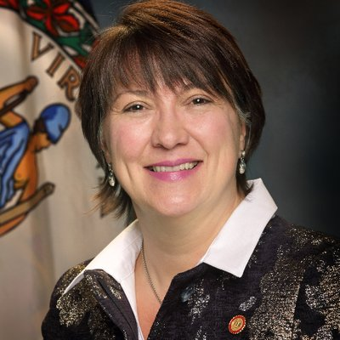
Bettina Ring was appointed Virginia Secretary of Agriculture & Forestry by Governor Ralph Northam in 2018. Previously, Ring was appointed state forester by Gov. Terry McAuliffe. Bettina Ring also served as senior vice president of family forests for the American Forest Foundation.
She also spent 14 years at the Virginia Department of Forestry, leaving the agency in 2001 as deputy state forester. In that role she was responsible for operations and helped develop and implement a new mission, vision and strategic plan for the department. In the years following her DOF service, Ring held various leadership positions within nonprofit organizations focusing on natural resources management and conservation, including the Colorado Coalition of Land Trusts, The Wilderness Land Trust and the Bay Area Open Space Council.

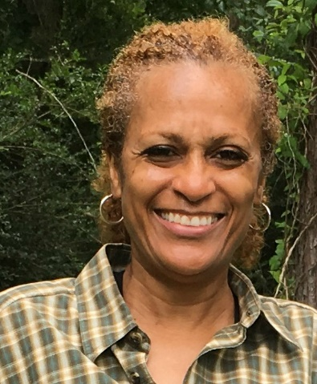
Vickie Roberts - Ratliff

Roberts-Ratliff is a fourth-generation landowner in Mississippi, where she and her mother own property designated as an agroforestry demonstration site. Roberts-Ratliff also serves as a program assistant for the Georgia Conservation Districts, and assists landowners, especially female and African-American landowners, with conservation practices and forest management plans. She is the author of the book “Roberts Rules of Land Retention.”

Joe Maroon
Joe Maroon is the executive director for the Virginia Environmental Endowment. Maroon has more than 30 years of experience with natural resource issues, working on Chesapeake Bay restoration, land conservation, stormwater management and nonpoint source pollution. Prior to this role, Maroon served as the agency director for the Virginia Department of Conservation and Recreation for two gubernatorial terms and as the Virginia Executive Director of the Chesapeake Bay Foundation for more than 16 years.

TUESDAY AFTERNOON TOURS
12 NOON – 5:00 PM
Lunch will be provided during tour stops.

Tour #1: Agriculture
The agriculture tour will visit farms in east central Virginia who have built successful, profitable farming operations through conservation and a providing their community with valuable ecosystem services. Recognizing, supporting and paying for agriculture’s ecosystem services - through government programs and new market based approaches – will be explored and discussed. The tour will highlight:

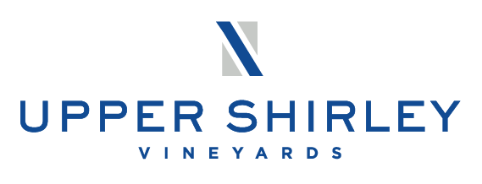
Upper Shirley Vineyards – Lunch and speakers from Upper Shirley and Shirley Plantation. Upper Shirley Vineyards is next door to Shirley Planation. Shirley Planation is the oldest family owned business in North America dating back to 1638. Shirley Planation is Virginia’s first plantation (1613) and one of the first economic engines of the new world. A long list of great Americans were guests at Shirley such as Washington and Jefferson. During the Revolution, Shirley was a supply center for the Continental Army. The mother of General Robert E. Lee was born at Shirley. Charles Carter, owner of Shirley Planation, serves as a Director on the Colonial Soil & Water Conservation District and will welcome tour participants.

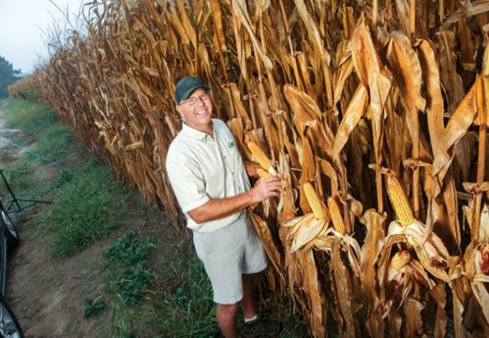
Renwood Farm – The Hulas are considered some of the most progressive crop producers in Virginia. Featured in numerous journals and winners of many awards the Hulas prove that profitability and conservation of natural resources go hand-in-hand. The Hulas are currently the world record holder for corn yield. Their farm, located on the James River, uses innovative precision technology. On site take part in conversation with David and Stanley Hula regarding production and precision agriculture, participate in a drone demonstration by Hezon Systems Inc in cooperation with the VA Department of Conservation & Recreation staff and tour the antique tractor museum on the premises.

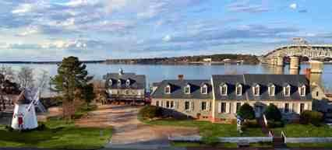
Tour #2: Education & Coastal Topics
This tour will focus on environmental education as well as coastal topics. Attendees will visit the Virginia Watermen’s Museum in Yorktown followed by a trip to the Virginia Institute for Marine Science.
The Watermen’s Museum is located on the Yorktown, Virginia waterfront and demonstrates the role Chesapeake Bay Watermen, from pre-colonial to modern times, have played in the shaping of our nation. Enjoy lunch by the river while hearing from key partners in our work including the Chesapeake Bay Foundation. Then view a living shoreline, experience the historic Schooners and more. Learn more: https://watermens.org/
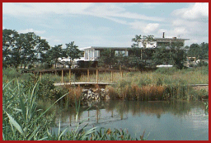
The Virginia Institute of Marine Science (VIMS) has a three-part mission to conduct research in coastal ocean and estuarine science, educate students and citizens, and provide advisory service to policy makers, industry, and the public. VIMS provides these services to Virginia, the nation, and the world. Chartered in 1940, VIMS is currently among the largest marine research and education centers in the United States. Participants will visit the teaching marsh a one-acre site restored to marshland for both practical and educational purposes. The marsh is designed and maintained by VIMS wetlands experts to naturally remove contaminants from Coleman Bridge storm water runoff, improving water quality in the York River. Learn more about the Virginia Institute of Marine Science at: http://ccrm.vims.edu/wetlands/teaching_marsh/index.html

Tour #3: Forestry & Urban Topics
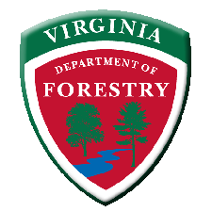
This tour will touch on a wide variety of topics that will demonstrate the positive impact various conservation efforts in the state have had on forested and private lands, urban areas, and the economy. In partnership with the Virginia Department of Forestry (VDOF) and the Virginia Conservation Assistance Program (VCAP), participants will enjoy walks, talks, and interactive sessions on forestry and urban stormwater initiatives - as well as the intersection of these two disciplines.

From Williamsburg, this tour will travel to the New Kent Forestry Center for a “lunch and learn” introduction to the center, the department, and their many impactful programs. We will also hear from a panel of representatives including VDOF’s Tree Improvement Program, City of Newport News Waterworks, and Dominion Energy.
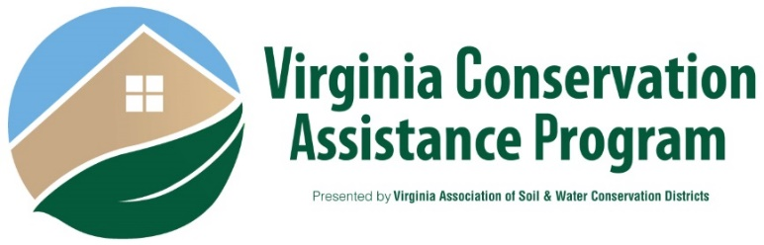
The tour will continue with an overview of New Kent Forestry Center facilities, before boarding the bus to learn more about VCAP and urban initiatives across the state. Before returning to Williamsburg, we will stop for a visit of one of our many urban stormwater Best Management Practices (BMPs). Participants will learn how VCAP, just a small pilot program a few years ago, has grown to be the latest in-demand effort of the Virginia Association of Soil and Water Conservation Districts (VASWCD) and participating districts.

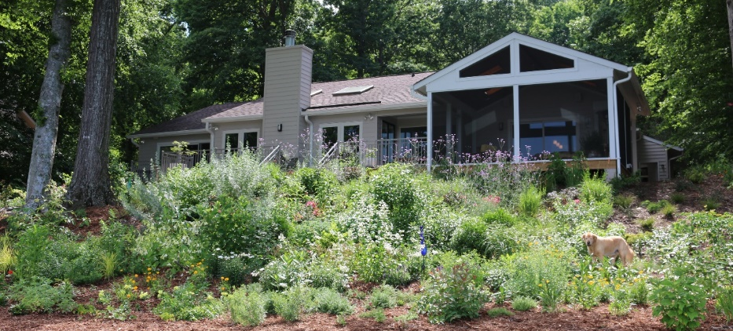

Tour #4: Historic Area
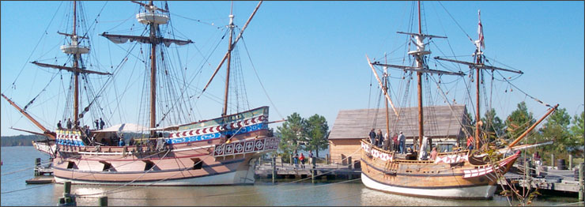
This tour will feature a visit to Historic Jamestowne, where the first successful English colony in North America began in 1607. Enjoy one of the most treasured and historic attractions along the beautiful James River. New facility, programs, and interpretive experiences convey the history of America's Birthplace on the exact land where it occurred.

Lunch will be provided on site by the Dale House Cafe. Following a one-hour guided tour, you will be able to visit the 1620 "New Towne"- an expansion of the Virginia's first capital, view ongoing archaeological investigations, the National Park Service visitor center and the archaeology museum. The site is jointly administered by National Park Service (1500 acres) and Preservation Virginia (22.5 acres).

Before heading back to the Williamsburg Lodge, we will make a 30-minute stop at the NPS Glasshouse where interpreters use the same techniques and tools employed by glassblowers of 1608 to produce items for sale. English America's first industry was glassblowing. Learn More: https://historicjamestowne.org/

DISCOUNTED HISTORIC AREA TICKET
Visit the Registration Desk and purchase an exclusive, discounted historic area ticket good for the duration of the conference and includes access to Colonial Williamsburg’s Historic Area sites and museums.
With this access pass, visit our historic trades including the Blacksmith and Cooper to see how they still use 18th century tools and methods. Tour our homes and government buildings and stroll the gardens. Don’t forget the two world class Art Museums which house the largest colonial period archaeological collection in the U.S.
This special discounted rate is only available at the conference registration desk.

TUESDAY, AUGUST 7, 2018
6:00 PM Networking & Reception, Exhibit Hall Open

6:30- 9:00 PM Celebrate Southeast - Banquet Dinner &
SECDEA Live Auction Virginia Room A-F
The letters “BQ” are included on your nametag if you purchased this meal in advance.

We can’t end the meeting without going out in style! Join us a final time in the Virginia Ballroom for food, beverages and dancing to the Shanty Grass Band. We believe that music and other social activities have been embedded within the culture of every group of people since the beginning of time. So, for Watermen, it is impossible to tell the story of their history, culture or their daily lives without telling part of that story through music, dance, storytelling, and art. As their name implies – Shanty Grass - they perform Sea Shanties and Bluegrass, as well as Traditional and Modern Folk Music, Country and Light Rock.

In between jam sessions, the SECDEA will have its auction, so bring deep pockets in support of the organization. Also, the Tennessee Association of Conservation Districts will share what is in store for the 2019 NACD Southeast Regional Meeting in Gatlinburg and the 2019 NACD Annual Meeting in San Antonio.

WEDNESDAY, AUGUST 8, 2018
8:00 AM – 4:00 PM National Conservation Planning Partnership Colony E
9:00 AM – 3:00 PM NACD RPG Meetings
Coastal (Starting at 8AM) Tidewater A
Forestry Tidewater B
Invasive Species Piedmont C
Public Lands Alleghany A
Urban & Community Alleghany B
Tribal Alleghany C

notes

ﬂoor plans

